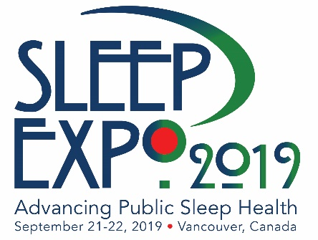
FOR IMMEDIATE RELEASE
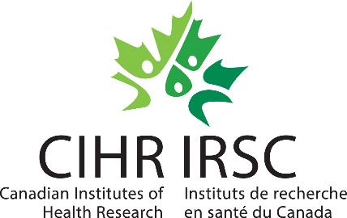
World Sleep Society
Allan O’Bryan, Executive Director
obryan@worldsleepsociety.org
+1.507.316.0084
sleepexpo.org

WORLD SLEEP SOCIETY & PARTNERS BRING PATIENT
‘SLEEP EXPO’ TO VANCOUVER, CANADA FOR THE FIRST TIME

ROCHESTER, MN –March 13, 2019— World Sleep Society (founded by World Association of Sleep Medicine and World Sleep Federation) has collaborated with the Canadian Sleep Society, Canadian Institutes of Health Research, Wake Up Narcolepsy and Hypersomnia Foundation to host the first-ever, international summit for patients with sleep disorders: SLEEP EXPO. The sleep expo will take place Saturday, September 21 through Sunday, September 22, 2019. The venue selected for the Sleep Expo is the Vancouver Convention Centre in Vancouver, Canada, located on British Columbia’s waterfront with mountain views.
Sleep Expo 2019 will provide patients unmatched opportunities to learn and experience scientific ideas and new research in sleep medicine with the aim of advancing sleep health worldwide. Sleep Expo 2019’s program will be arranged into four types of sessions: sleep disorder lecture series, facilitator-led discussions, sleep-related author tables and Meet the Expert panels. All sessions will be led by world-renowned, established sleep medicine professionals. Partners include patient organizations advocating and educating individuals about insomnia, sleep apnea, restless legs syndrome, hypersomnia and other sleep disorders.
“Sleep impacts nearly every facet of health,” explains Charles Samuels, MD, CCFP, DABSM, Medical Director of the Centre for Sleep and Human Performance and President of the Canadian Sleep Society. “This is a very unique opportunity for the Canadian Sleep Society, along with the World Sleep Society, to offer the public direct access to sleep experts from around the world to address questions and provide world-class, evidenced-based information regarding the diagnosis and management of sleep disorders. One of the primary goals of both organizations is to promote sleep health. What better way to do this than in this international setting with the best sleep experts in the world!”
John Fleetham MD, FRCP(C) of University of British Columbia, World Sleep Society and Canadian Sleep Society says of the Sleep Expo, “Poor sleep equals poor health so I’m delighted that the World Sleep Society meeting in Vancouver is holding a patient awareness day.”
Join us to learn about recent advances in sleep medicine including up-to-date clinical and basic research. Registration is free. More information is available on www.sleepexpo.org.
###
About World Sleep Society
Sleep Expo 2019 and World Sleep 2019 are organized by World Sleep Society, an international association whose mission is to advance sleep health worldwide. Sleep Expo information is kept current on www.sleepexpo.org. World Sleep Society and the International RLS Study Group have collaborated to launch a sleep directory aiming to globally connect healthcare professionals and patients in their search for sleep experts at sleepdirectory.org. Follow on Twitter @_WorldSleep and facebook.com/WASMF.

About Canadian Sleep Society
The Canadian Sleep Society has a vision; Healthy sleep for healthy Canadians. The society is a national organization committed to improving sleep for all Canadians through support for research, promotion of high quality clinical care, education of professionals and the public, and advocacy for sleep and sleep disorders medicine. Learn more at www.css-scs.ca.

About Canadian Institutes of Health Research
Canadian Institutes of Health Research (CIHR) is Canada’s federal funding agency for health research. Composed of 13 Institutes, we collaborate with partners and researchers to support the discoveries and innovations that improve our health and strengthen our health care system.

